If you are preparing your own taxes, make sure to read this page carefully to make sure you get the correct tax refund!

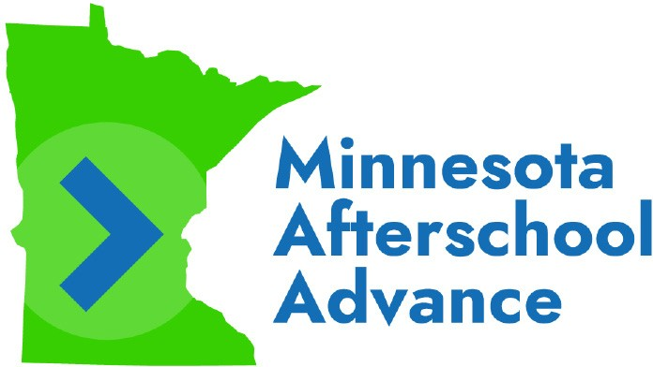
TIPS FOR PREPARING YOUR TAXES ON YOUR OWN
Claiming the Minnesota K-12 Education Tax Credit is how the money Minnesota Afterschool Advance (MAA) advanced to you gets repaid. If you choose to prepare and file your 2022 taxes on your own, here’s some important information you should know to do it correctly. Failing to do so will result in a smaller refund.

Required Forms
To successfully claim the Tax Credit, you must include Form M1ED and Form M1REF with your Minnesota Tax Return. These forms will help you confirm your eligibility to claim the Tax Credit and calculate the amount you can claim. If you do not include these forms, you will not get the correct refund.
If you are using TurboTax or similar software to prepare your taxes, make sure to indicate you want to claim the K-12 Education Tax Credit when asked.

Itemized Receipts
We have included with this mailing a receipt (on blue paper) for each activity that your children participated in through MAA. These receipts will help you complete your taxes, and the Minnesota Department of Revenue requires you keep them in case you get audited.
If you never received a receipt or lost it, please contact the MAA team at (612)-440-9342 or maa@youthprise.org.

Filing Status
By state law, you cannot choose the filing status “married filing separately” and claim the Tax Credit.

Requesting Assistance
MAA cannot provide you with tax advice. If you need assistance completing your taxes and claiming the Tax Credit or are worried about doing it correctly, we encourage you utilize the free tax preparation services in partnership with MAA or other services available in your community. More information about how to use this option is listed on the green paper included in this mailing.

GET THE RIGHT REFUND!

Make sure your tax return includes Form M1ED &
Form M1REF before submitting it.

