SHARE THIS LETTER WITH YOUR TAX PREPARER TO MAKE SURE YOU GET THE CORRECT REFUND

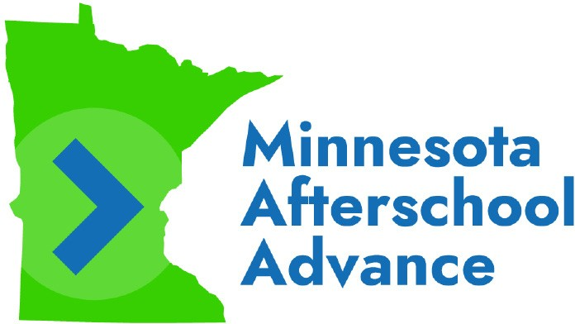
IMPORTANT INSTRUCTIONS FOR YOUR TAX PREPARER

To: Family’s Tax Preparer
From: Minnesota Afterschool Advance
Re: Claiming the MN K-12 Education Tax Credit
The family for whom you are preparing a 2022 tax return is a participant in Minnesota Afterschool Advance (MAA). It is critical to check the family’s eligibility for the K-12 Education Tax Credit and claim it for them if they are eligible. Please read the following carefully to ensure the family receives the correct tax refund.

Make Sure the Family Claims the Tax Credit, If Eligible
As you prepare the family’s Minnesota tax return, please confirm their eligibility for the MN K-12 Education Tax Credit and, assuming they are eligible, file the following forms along with their Minnesota tax return:
- Minnesota Form M1ED
- Minnesota Form M1REF.
We sent the family copies of the itemized receipts required to claim the Tax Credit (they’re on blue paper). The family should contact MAA if they need additional copies of any receipts.

How Minnesota Afterschool Advance Works
MAA uses the Minnesota Department of Revenue’s Credit Assignment Process (M.S. 290.0679) to loan the family the amount of the MN K-12 Education Tax Credit (M.S. 290.0674) they are eligible to claim for certain afterschool activities or computer hardware in exchange for an assignment of that portion of their tax refund. This is a no- interest, no-fee loan that is repaid automatically out of the family’s available tax refund, if any. You can learn more at www.mnafterschool.org/how-it-works.
As a result, it is critical that the family file the forms required to claim the MN K-12 Education Tax Credit for 2022, assuming they are eligible. This will ensure the loan is repaid with the Tax Credit dollars as intended. Failing to do so may result in the loan being repaid out of another part of the family’s refund (unfairly reducing the amount they receive back) or the loan not being repaid at all, preventing those dollars from being used again next year to aid the same family or another family.

Additional Resources on the Tax Credit and MAA
Additional information on the Tax Credit and the associated assignment process is available on the Minnesota Department of Revenue website.
Do not ignore these instructions. Doing so will prevent the family from getting the correct refund and require the filing of an amended return to fix. If you are confused or have questions, contact the MAA Team at (612)-440-9342 or maa@youthprise.org.

